Architecture, Block & FSM State Diagrams
Project: Adaptive Multi-Junction Traffic Grid Controller (AMTGC)
Author: Aakash Rayal
Organization: ElevanceSkills VLSI Internship Program

1. System Block Diagram & Interconnect Hierarchy
The Adaptive Multi-Junction Traffic Grid Controller (amtgc_top) comprises three interconnected sub-modules organized in a strict two-tier hierarchical tree.
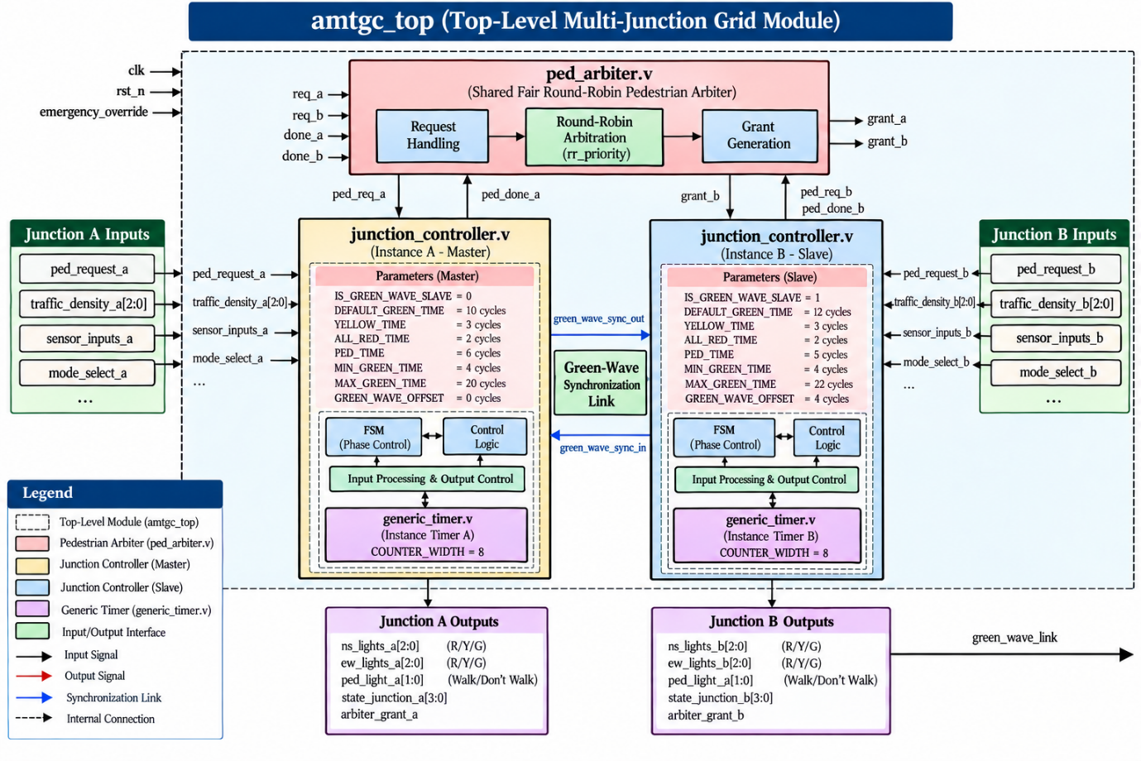

2. Moore Finite State Machine (FSM) State Diagram
Both Junction A and Junction B are synthesized from the identical junction_controller.v Moore FSM. Light heads depend purely on the active state register (state_reg), guaranteeing zero combinational glitching across the physical lamp driver circuitry.

2. Moore Finite State Machine (FSM) State Diagram

Both Junction A and Junction B are synthesized from the identical junction_controller.v Moore FSM. Light heads depend purely on the active state register (state_reg), guaranteeing zero combinational glitching across the physical lamp driver circuitry.

2.1 Mermaid FSM Transition Diagram
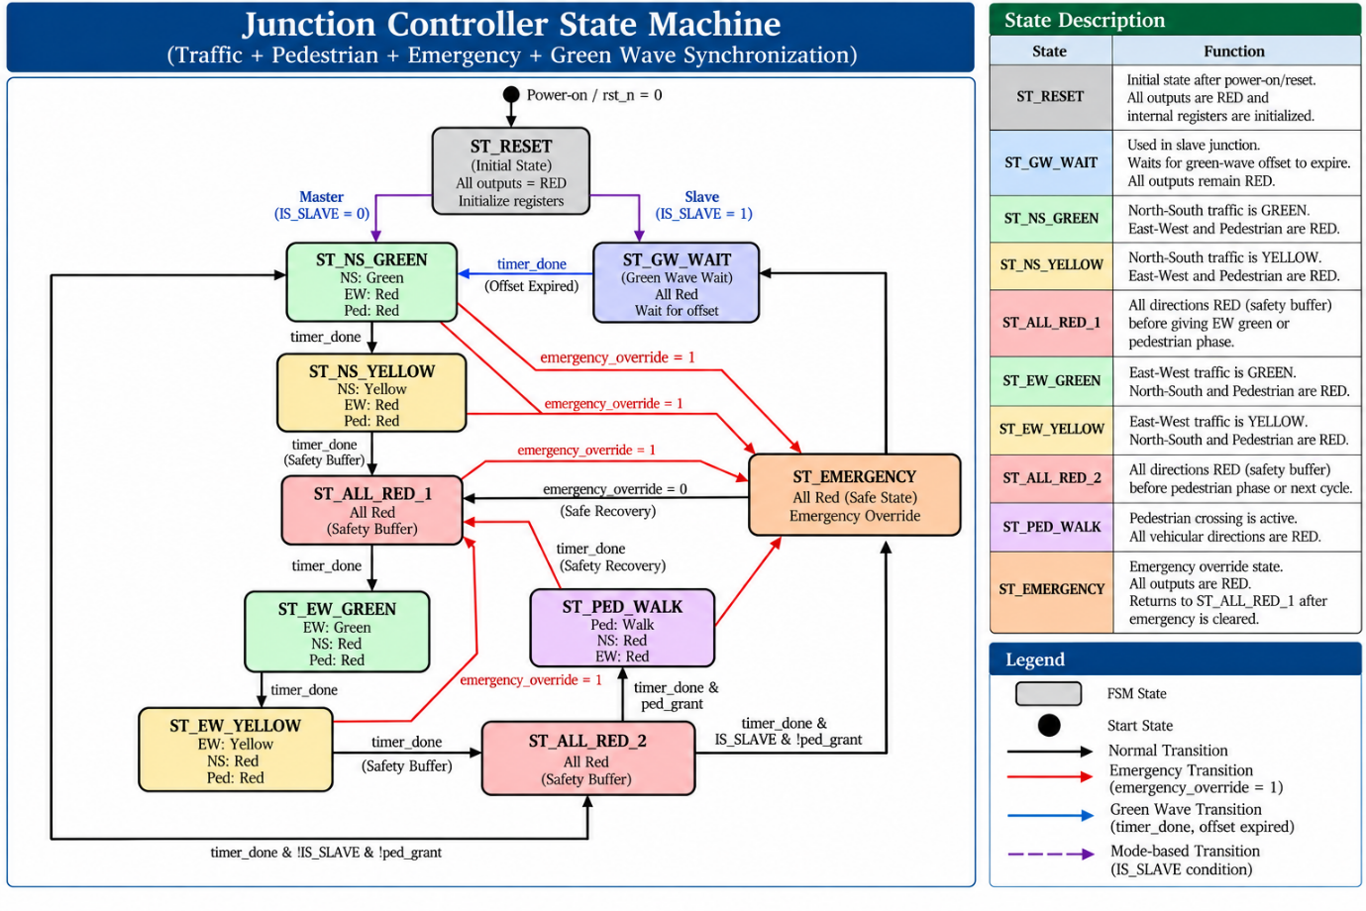

3. Moore State Encoding & Output Mapping Table
State Constant | State Code (state_reg[3:0]) | NS Lights (ns_lights[2:0]) | EW Lights (ew_lights[2:0]) | Pedestrian Light (ped_light[1:0]) | Functional Phase Description
ST_RESET | 4'd0 | 3'b100 (Red) | 3'b100 (Red) | 2'b01 (Don't Walk) | Asynchronous Reset initialization state.
ST_GW_WAIT | 4'd1 | 3'b100 (Red) | 3'b100 (Red) | 2'b01 (Don't Walk) | Green-Wave offset alignment delay state (Slave only).
ST_NS_GREEN | 4'd2 | 3'b001 (Green) | 3'b100 (Red) | 2'b01 (Don't Walk) | North-South arterial vehicular flow enabled.
ST_NS_YELLOW | 4'd3 | 3'b010 (Yellow) | 3'b100 (Red) | 2'b01 (Don't Walk) | North-South traffic caution clearance interval.
ST_ALL_RED_1 | 4'd4 | 3'b100 (Red) | 3'b100 (Red) | 2'b01 (Don't Walk) | Non-zero safety gap clearing the intersection before EW Green.
ST_EW_GREEN | 4'd5 | 3'b100 (Red) | 3'b001 (Green) | 2'b01 (Don't Walk) | East-West cross-street vehicular flow enabled.
ST_EW_YELLOW | 4'd6 | 3'b100 (Red) | 3'b010 (Yellow) | 2'b01 (Don't Walk) | East-West traffic caution clearance interval.
ST_ALL_RED_2 | 4'd7 | 3'b100 (Red) | 3'b100 (Red) | 2'b01 (Don't Walk) | Non-zero safety gap prior to Pedestrian or NS Green phase.
ST_PED_WALK | 4'd8 | 3'b100 (Red) | 3'b100 (Red) | 2'b10 (Walk) | Dedicated all-vehicular red pedestrian crossing phase.
ST_EMERGENCY | 4'd9 | 3'b100 (Red) | 3'b100 (Red) | 2'b01 (Don't Walk) | Priority override; all vehicular and pedestrian traffic halted.

4. Pedestrian Arbiter State Machine
The pedestrian arbiter operates as an independent, decoupled state machine that prevents starvation through fair round-robin token rotation:
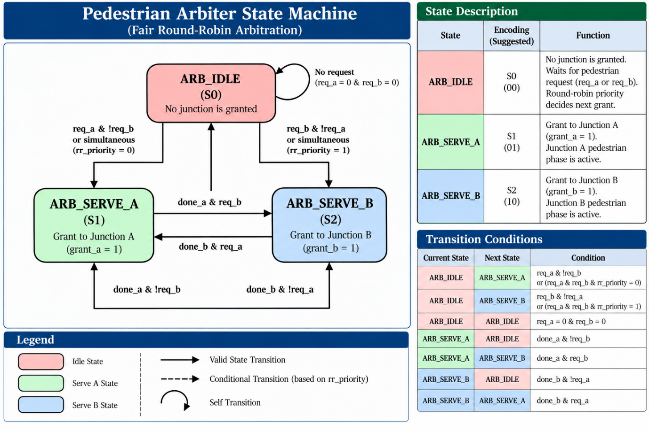Arbiter Handshake Sequence:
- req_a and req_b arrive concurrently from latched pedestrian pushbuttons.
- Arbiter evaluates rr_priority:
  - If rr_priority == 0: grant_a <= 1'b1, grant_b <= 1'b0, rr_priority <= 1'b1 (priority rotates to B).
  - If rr_priority == 1: grant_b <= 1'b1, grant_a <= 1'b0, rr_priority <= 1'b0 (priority rotates to A).
- The granted junction proceeds to ST_PED_WALK upon concluding its vehicular sequence.
- When ST_PED_WALK reaches timer_done, the junction strobes ped_done_to_arbiter = 1'b1.
- Arbiter immediately detects done and transfers the grant to the waiting second junction without entering idle, guaranteeing zero latency.

5. Traffic-Adaptive Dynamic Timing Architecture
The traffic-adaptive computation is deliberately calculated inside the junction controller rather than modifying generic_timer.v:
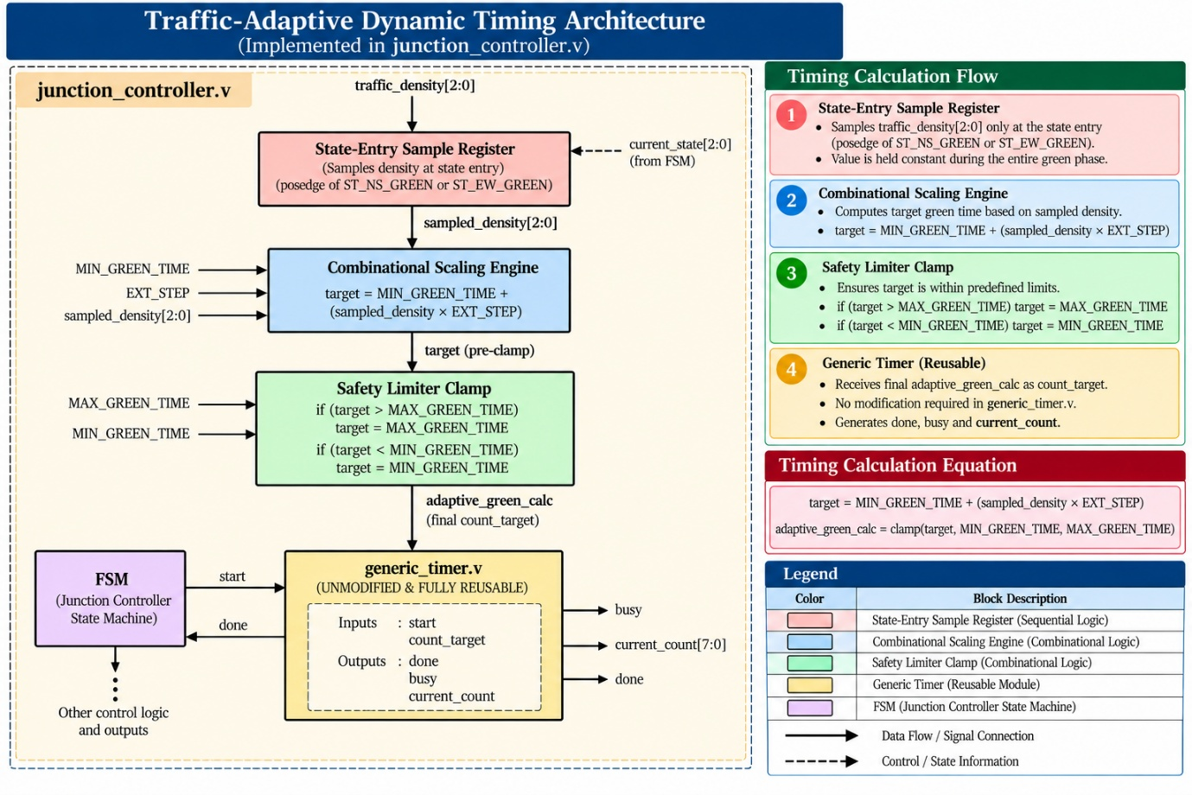Justification:
- Modifying generic_timer.v to embed traffic density logic would break its reusability for standard fixed-duration states (Yellow, All-Red, Pedestrian Walk).
- By computing the dynamic target inside the controller and passing it across the existing count_target bus, generic_timer.v remains completely generic, pure, and reusable across any future timing requirements.

